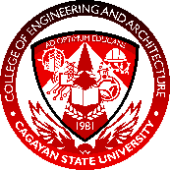 | Cagayan State University  COLLEGE OF ENGINEERING AND ARCHITECTURE, CARIG CAMPUS  COEA-SR04
Adviser Consultation Form
This form serves as a record for consultations regarding the research of the proponent(s). Student Researchers and Research Advisers are expected to have at least 10 consultation meetings per semester.

THESIS TITLE
Development of a Localized Real-Time Frequency Monitoring System for Structural Health Monitoring Using MEMS IMUs and ESP32 | Program | ECE
 | Major

PROPONENT(S)
Proponent(s) | Talosig, Jan Clyde T.
Research Adviser | ENGR. CRISTOPHER R. CAPILI

CONSULTATIONS
Date | Time | Place | Topic/Area/Content of Consultation | Adviser’s Signature
Aug. 27, 2026 | 1:00 PM | COEA LAB | Bridge operating permit; clarified hardware design and external battery placement/USB-C connection with Engr. Cristopher R. Capili.

